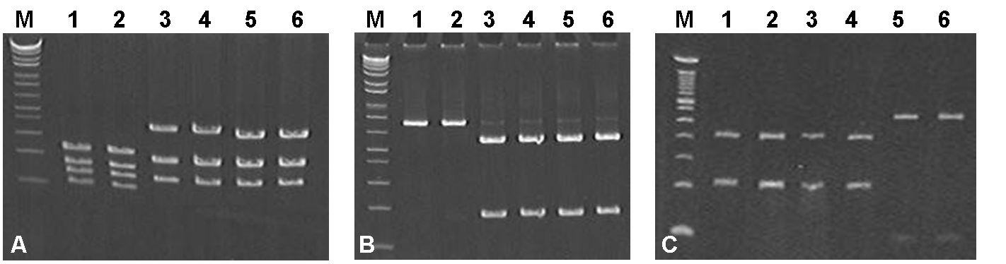

Figure 1: Digestion profile of a fragment (690 base pairs) of the amplified coding region of the mitochondrial gene of subunit 2 of NADH dehydrogenase, using PCR-RFLP. A) Amplicon digested by restriction enzyme DdeI. Lines 1 and 2: N. rossii. Lines 3 and 4: N. coriiceps Richardson, 1844. Lines 5 and 6: N. neglecta Nybelin, 1951; B) Amplicon digested by restriction enzyme HindIII. Lines 1 and 2: N. rossii. Lines 3 and 4: N. coriiceps Richardson, 1844. Lines 5 and 6: N. neglecta Nybelin, 1951; C) Amplicon digested by restriction enzyme RsaI. Lines 1 and 2: N. coriiceps Richardson, 1844. Lines 3 and 4: N. neglecta Nybelin, 1951. Lines 5 and 6: N. rossii. M: 1kb Plus Ladder (Invitrogen).

